**TrafficTelligence: Advanced Traffic Volume Estimation with Machine Learning**

**Introduction :**

TrafficTelligence is an advanced system that uses machine learning algorithms to estimate and predict traffic volume with precision. By analyzing historical traffic data, weather patterns, events, and other relevant factors, TrafficTelligence provides accurate forecasts and insights to enhance traffic management, urban planning, and commuter experiences.

**Scenario 1: Dynamic Traffic Management** TrafficTelligence enables dynamic traffic management by providing real-time traffic volume estimations. Transportation authorities can use this information to implement adaptive traffic control systems, adjust signal timings, and optimize lane configurations to reduce congestion and improve traffic flow.

**Scenario 2: Urban Development Planning** City planners and urban developers can leverage TrafficTelligence predictions to plan new infrastructure projects effectively. By understanding future traffic volumes, they can design road networks, public transit systems, and commercial zones that are optimized for traffic efficiency and accessibility.

**Scenario 3: Commuter Guidance and Navigation** Individual commuters and navigation apps can benefit from TrafficTelligence's accurate traffic volume estimations. Commuters can plan their routes intelligently, avoiding congested areas and selecting optimal travel times based on predicted traffic conditions. Navigation apps can provide real-time updates and alternative routes to improve overall travel experiences.

**Technical Architecture:**

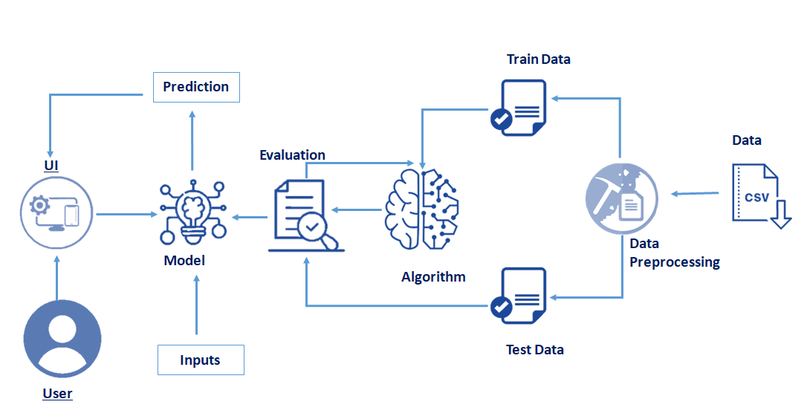

**Project Flow:**

* User interacts with the UI (User Interface) to enter the input values.
* Entered input values are analysed by the model which is integrated.
* Once the model analyses the input the prediction is showcased on the UI.

To accomplish this, we have to complete all the activities and tasks listed below

* Data Collection.
  + Collect the dataset or Create the dataset
* Data Pre-processing.
  + Import the Libraries.
  + Importing the dataset.
  + Checking for Null Values.
  + Data Visualization.
  + Taking care of Missing Data.
  + Feature Scaling.
  + Splitting Data into Train and Test.
* Model Building
  + Import the model building Libraries
  + Initializing the model
  + Training and testing the model
  + Evaluation of Model
  + Save the Model
* Application Building
  + Create an HTML file
  + Build a Python Code
  + Run the App

**Activity 1: Collect the dataset**

ML depends heavily on data, without data, it is impossible for an “AI” model to learn. It is the most crucial aspect that makes algorithm training possible. In Machine Learning projects, we need a training **data set**. It is the actual **data set** used to train the model for performing various actions.

**Activity 1.1: Understand the data**

Data contains all the meta information regarding the columns described in the CSV files. we have provided 5 CSV files:

**Column Description:**

1. **Holiday**: Refers to a specific day or time period when people are not working, such as public holidays or seasonal breaks, which can affect patterns like traffic volume or weather conditions.
2. **Temp**: Short for temperature, this indicates the degree of heat or cold in the environment, typically measured in degrees Celsius (°C) or Fahrenheit (°F). It affects how people behave (e.g., traffic) and how weather is perceived (e.g., snow or rain).
3. **Rain**: Indicates whether it is raining, typically a binary value (yes or no), and represents precipitation that affects visibility, road conditions, and traffic patterns.
4. **Snow**: Indicates whether there is snowfall, which can impact road safety, visibility, and traffic flow, and can be an important factor in weather predictions.
5. **Weather**: A general term that describes the overall atmospheric conditions at a given time, which can include temperature, precipitation, cloud cover, wind, and other factors.
6. **Date**: Represents the specific calendar date when the data was recorded, such as "March 4, 2025." This helps track patterns or events over time.
7. **Time**: Refers to the specific time of day the data was recorded, which can help analyze patterns in traffic, weather, or other conditions at different hours (e.g., morning rush hour, night).
8. **Traffic Volume**: Refers to the amount of vehicle traffic on a specific road or highway, measured as the number of vehicles passing a point in a given time period. It is influenced by factors like time of day, weather, and holidays.

Activity 2: **Data Pre-processing**

Data Pre-processing includes the following main tasks

o   Import the Libraries.

o   Importing the dataset.

o   Checking for Null Values.

o   Data Visualization.

o   Feature Scaling.

o   Splitting Data into Train and Test.

**Activity 2.1: Import Necessary Libraries**

It is important to import all the necessary libraries such as pandas, NumPy, matplotlib.

* **Numpy**- It is an open-source numerical Python library. It contains a multi-dimensional array and matrix data structures. It can be used to perform mathematical operations on arrays such as trigonometric, statistical, and algebraic routines.
* **Pandas-** It is a fast, powerful, flexible and easy to use open source data analysis and manipulation tool, built on top of the Python programming language.
* **Seaborn**- Seaborn is a Python data visualization library based on matplotlib. It provides a high-level interface for drawing attractive and informative statistical graphics.
* **Matplotlib**- Visualisation with python. It is a comprehensive library for creating static,animated, and interactive visualizations in Python
* **Sklearn** – which contains all the modules required for model building.

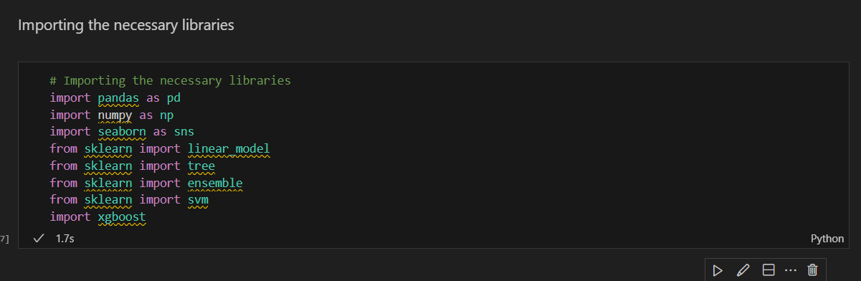

**Activity 2.2: Importing the Dataset**

* You might have your data in .csv files, .excel files
* Let’s load a .csv data file into pandas using read_csv() function.We will need to locate the directory of the CSV file at first (it’s more efficient to keep the dataset in the same directory as your program).

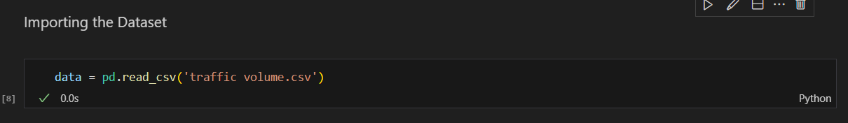

* If the dataset is in the same directory of your program, you can directly read it, without giving raw as r.
* Our Dataset weatherAus.csv  contains the following Columns
* Holiday -  working day or holiday
* Temp- temperature of the day
* Rain and snow – whether it is raining or snowing on that day or not
* Weather = describes the weather conditions of the day
* Date and time = represents the exact date and time of the day
* Traffic volume – output column

The output column to be predicted is Traffic volume.Based on the input variables we predict the volume of the traffic. The predicted output gives them a fair idea of the count of traffic.

Activity 2.3: **Analyse the data**

1. **head()**method is used to return top n (5 by default) rows of a DataFrame or series.

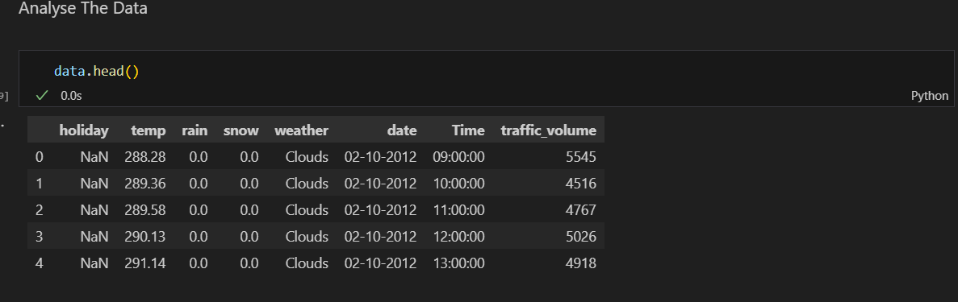

1. **describe()** method computes a summary of statistics like count, mean, standard deviation, min, max, and quartile values.

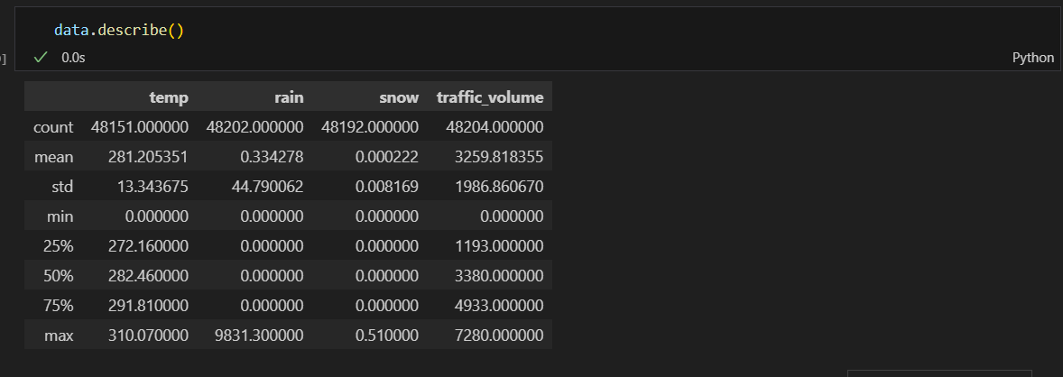

1. **info()**gives information about the data - paste the image here.

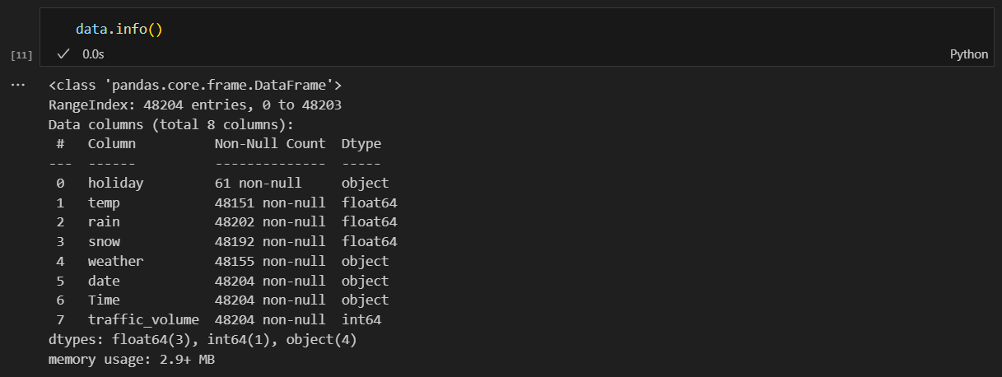

Activity 2.4: **Handling Missing Values**

1. The Most important step in data pre-processing is dealing with missing data, the presence of missing data in the dataset can lead to low accuracy.

2. Check whether any null values are there or not. if it is present then the following can be done.

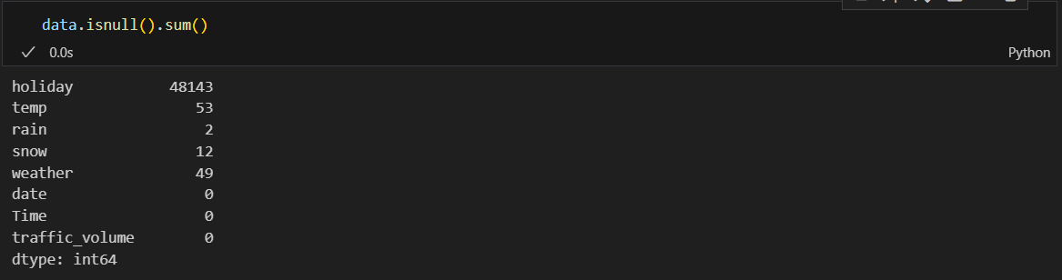

There are missing values in the dataset, we will fill the missing values in the columns.

3. We are using mean and mode methods for filling the missing values

* Columns such as temp, rain, and snow are the numeric columns, when there is a numeric column you should fill the missing values with the mean/median method. so here we are using the mean method to fill the missing values.
* Weather column has a categorical data type, in such case missing data needs to be filled with the most repeated/ frequent value. Clouds are the most repeated value in the column, so imputing with clouds value.

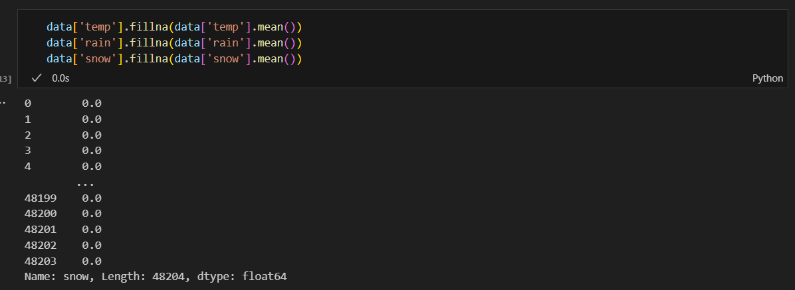

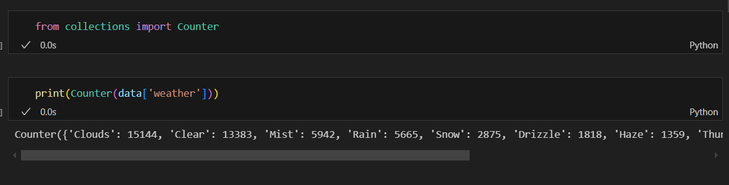

**Activity 2.5: Data Visualization**

Data visualization is where a given data set is presented in a graphical format. It helps the detection of patterns, trends and correlations that might go undetected in text-based data.  
  
Understanding your data and the relationship present within it is just as important as any algorithm used to train your machine learning model. In fact, even the most sophisticated machine learning models will perform poorly on data that wasn’t visualized and understood properly.

·         To visualize the dataset we need libraries called Matplotlib and Seaborn.

·         The  Matplotlib library is a Python 2D plotting library that allows you to generate plots, scatter plots, histograms, bar charts etc.

Let’s visualize our data using Matplotlib and seaborn library.  
Before diving into the code, let's look at some of the basic properties we will be using when plotting.

**xlabel:** Set the label for the x-axis.

**ylabel:** Set the label for the y-axis.

**title:** Set a title for the axes.

**Legend:** Place a legend on the axes.

**1. data.corr()** gives the correlation between the columns

Correlation is a statistical term describing the degree to which two variables move in coordination with one another. If the two variables move in the same direction, then those variables are said to have a positive correlation. If they move in opposite directions, then they have a negative correlation. -

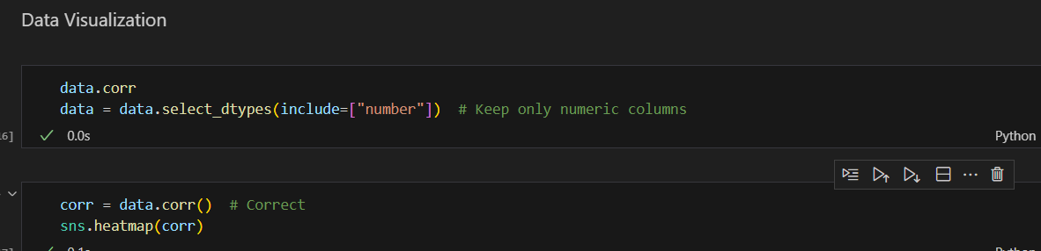

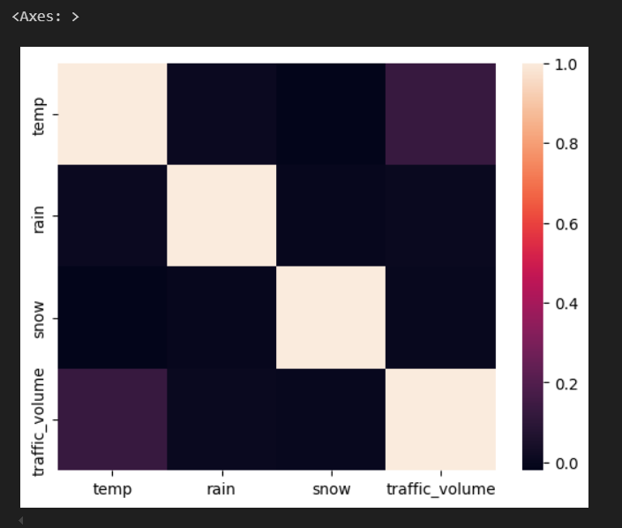

2. Pair Plot: Plot pairwise relationships in a dataset.

A pair plot is used to understand the best set of features to explain a relationship between two variables or to form the most separated clusters. It also helps to form some simple classification models by drawing some simple lines or making a linear separation in our data-set.

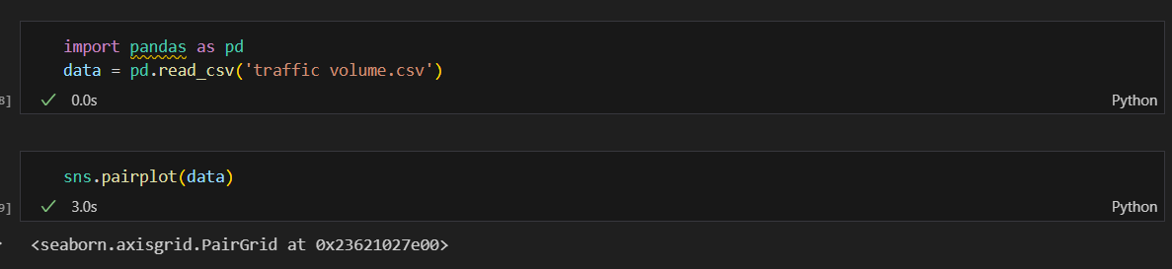 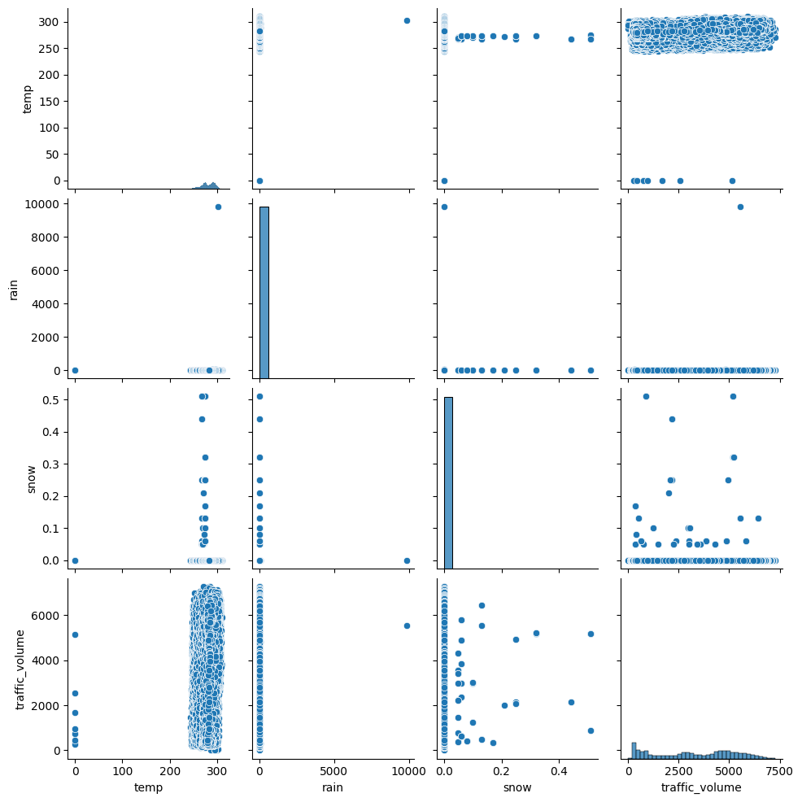

**3. Box Plot:**

Box-plot is a type of chart often used in explanatory data analysis. Box plots visually show the distribution of numerical data and skewness through displaying the data quartiles (or percentiles) and averages.

Box plots are useful as they show the average score of a data set. The median is the average value from a set of data and is shown by the line that divides the box into two parts. Half the scores are greater than or equal to this value and half are less.

 jupyter has a built-in function to create a boxplot called boxplot(). A boxplot plot is a type of plot that shows the spread of data in all the quartiles.

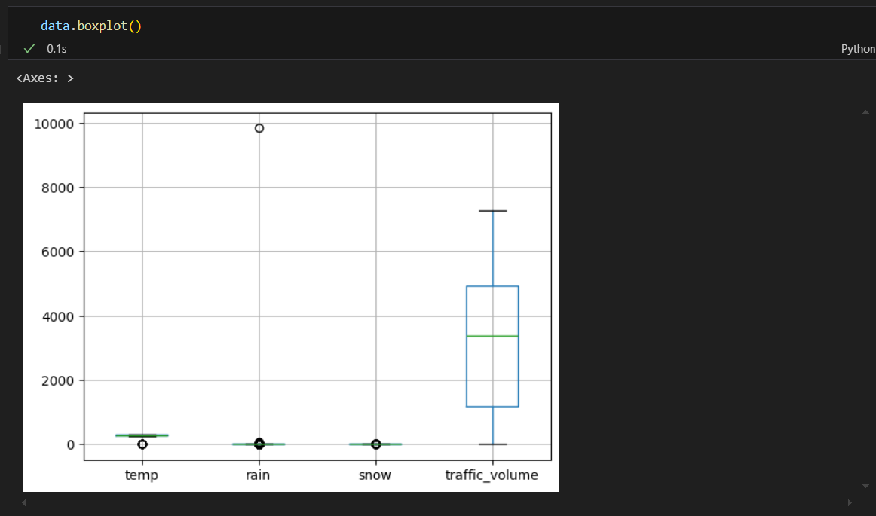

4. Data and time columns need to be split into columns so that analysis and training of the model can be done in an easy way, so we use the split function to convert date into the year, month and day. time column into hours, minutes and seconds.

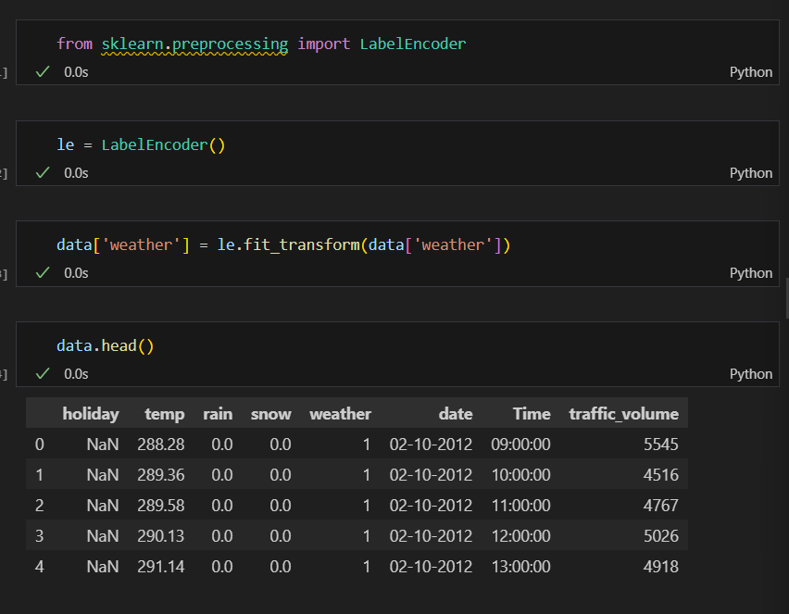

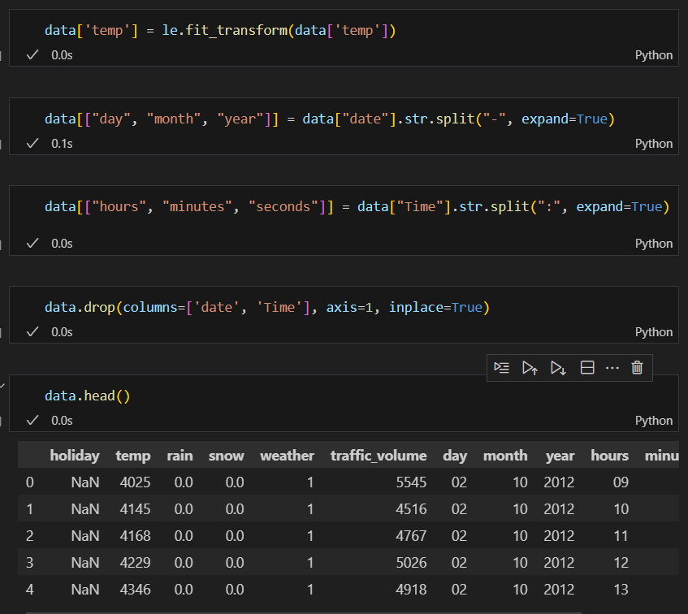

**Activity 2.6: Splitting the Dataset into Dependent and Independent variable**

·         In machine learning, the concept of the dependent variable (y) and independent variables(x) is important to understand. Here, the Dependent variable is nothing but output in dataset and the independent variable is all inputs in the dataset.

·         With this in mind, we need to split our dataset into the matrix of independent variables and the vector or dependent variable. Mathematically, Vector is defined as a matrix that has just one column.

Let’s split our dataset into independent and dependent variables.

y = data[traffic_volume] - independent

x = data.drop(traffic_volume,axis=1)

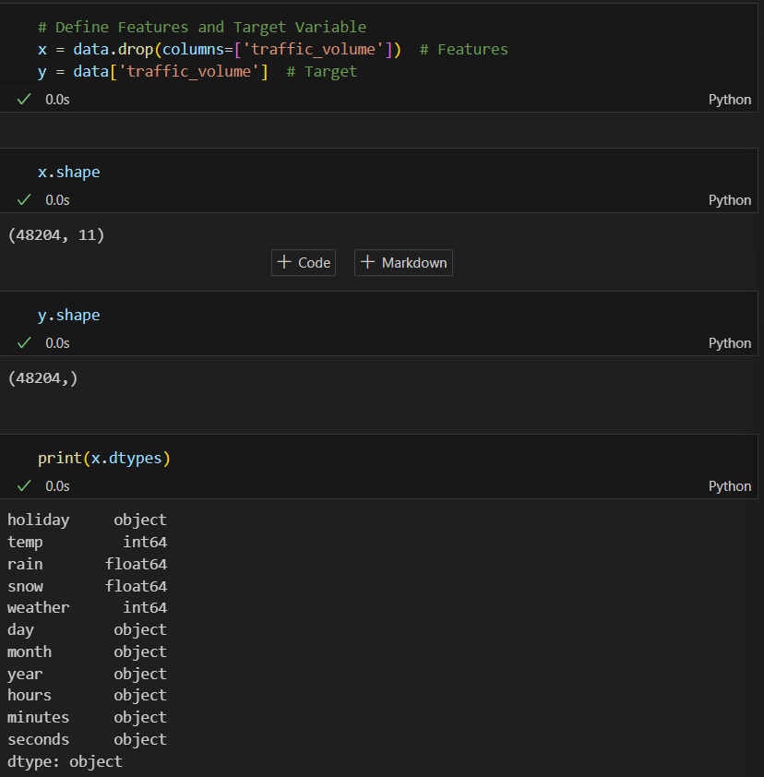 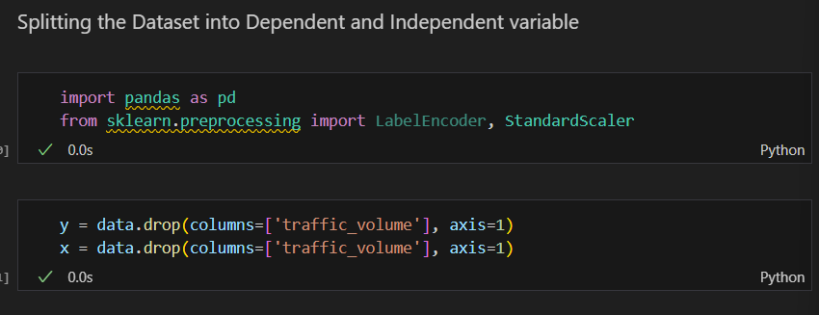

Activity 2.7: **Feature Scaling**

There is a huge disparity between the x values so  let us use feature scaling.

Feature scaling is a method used to normalize the range of independent variables or features of data.

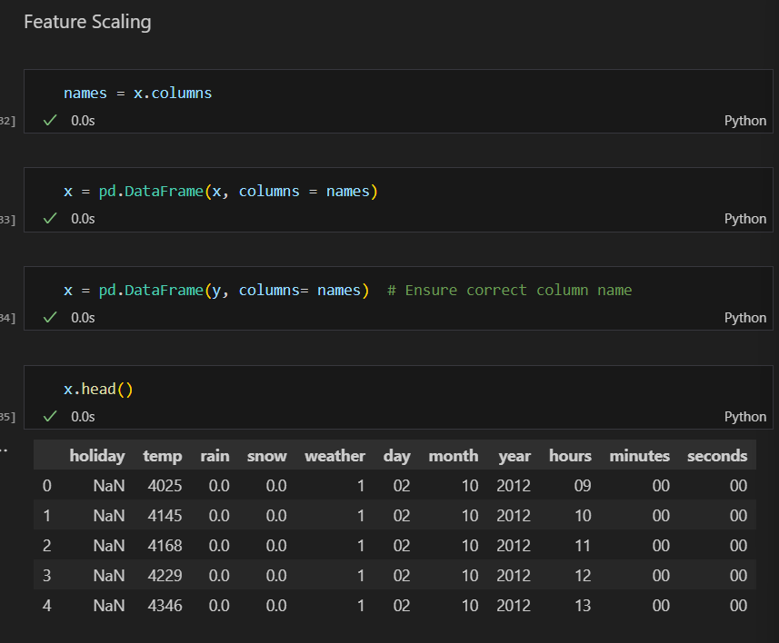

* After scaling the data will be converted into an array form
* Loading the feature names before scaling and converting them back to data frame after standard scaling is applied

Activity 6.7: **Splitting the data into Train and Test**

When you are working on a model and you want to train it, you obviously have a dataset. But after training, we have to test the model on some test datasets. For this, you will a dataset which is different from the training set you used earlier. But it might not always be possible to have so much data during the development phase. In such cases, the solution is to split the dataset into two sets, one for training and the other for testing.

* The train-test split is a technique for evaluating the performance of a machine learning algorithm.
* Train Dataset: Used to fit the machine learning model.
* Test Dataset: Used to evaluate the fit machine learning model.
* In general you can allocate 80% of the dataset to the training set and the remaining 20% to test.
* Now split our dataset into train set and test using train_test_split class from sci-kit learn library.

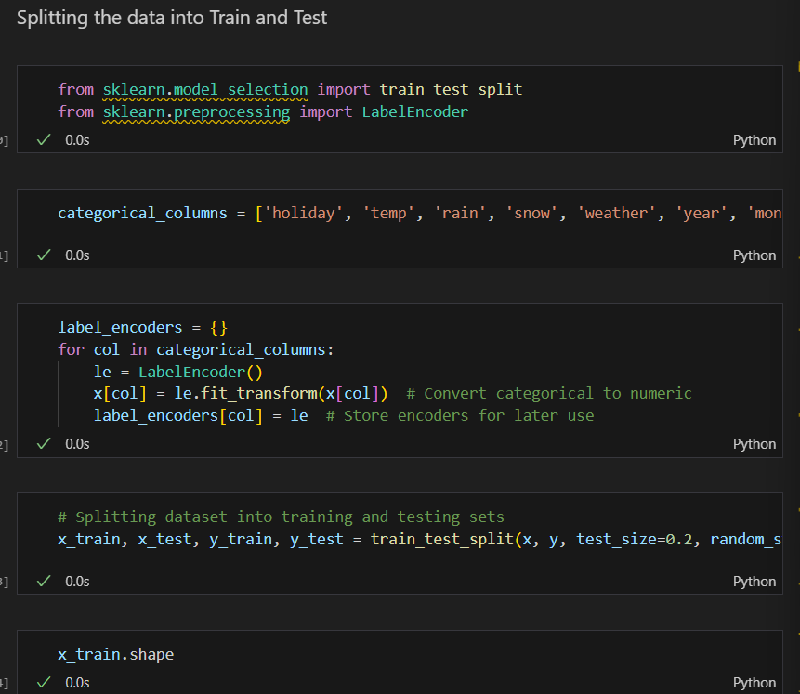

ACTIVITY 3: **Model Building**

The model building includes the following main tasks

o   Initializing the model

o   Training and testing the model

o   Evaluation of Model

o   Save the Model

Activity 3.1: Initializing the model

* Once after splitting the data into train and test, the data should be fed to an algorithm to build a model.
* There are several Machine learning algorithms to be used depending on the data you are going to process such as images, sound, text, and numerical values. The algorithms that you can choose according to the objective that you might have it may be Classification algorithms are Regression algorithms.

1. Linear Regression  
2. Decision Tree Regressor  
3.Random Forest Regressor  
4.KNN  
5.svm  
5.xgboost

Steps in Building the model:-

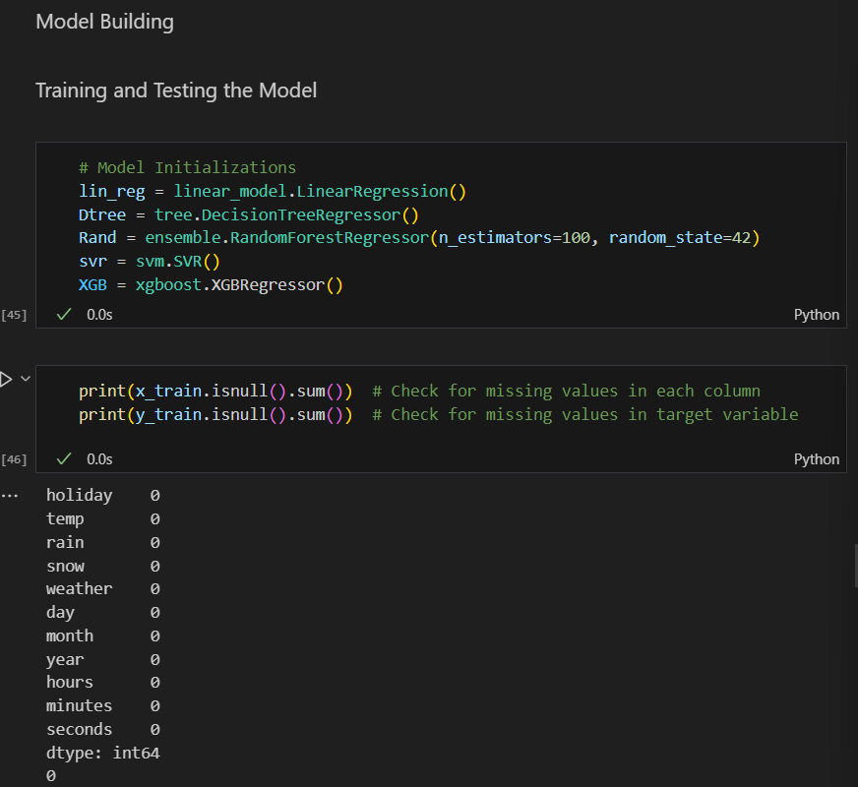

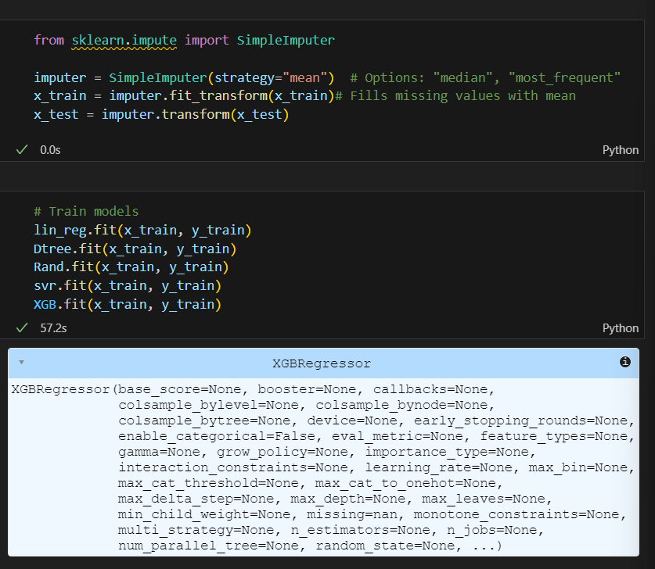

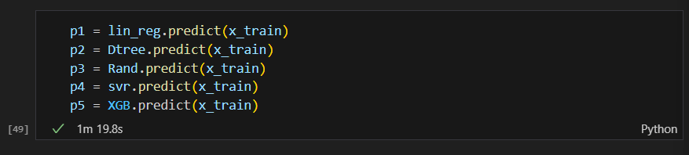

Activity 3.2: **Model Evaluation**

After training the model, the model should be tested by using the test data which is been separated while splitting the data for checking the functionality of the model.

**Regression Evaluation Metrics:**

These model evaluation techniques are used to find out the accuracy of models built in the Regression type of machine learning models. We have three types of evaluation methods.

* R-square_score
* RMSE – root mean squared error

**1. R-squared _score** -

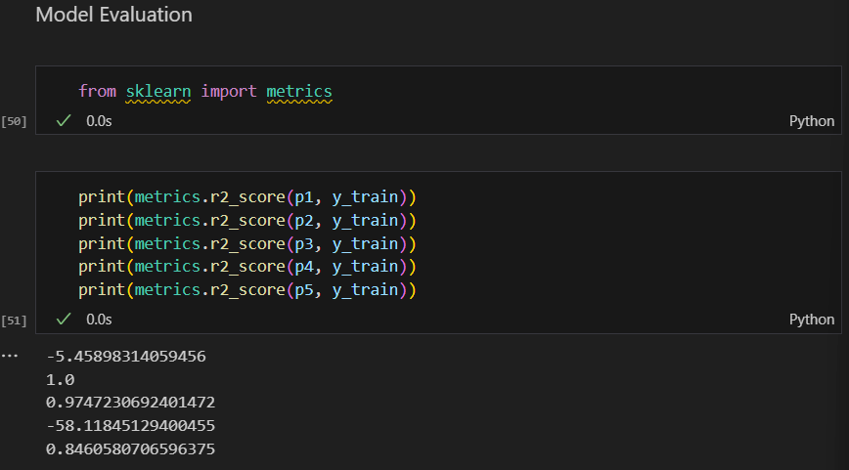

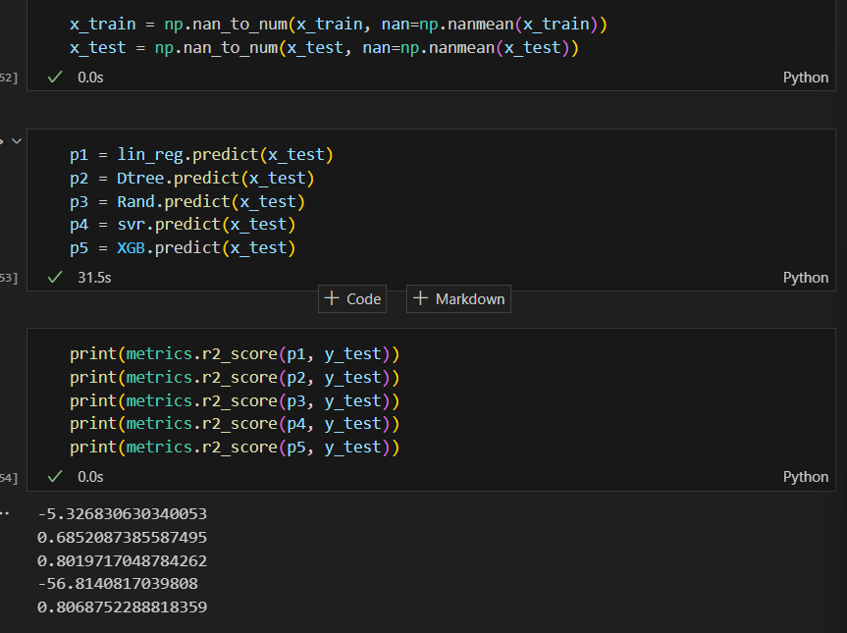

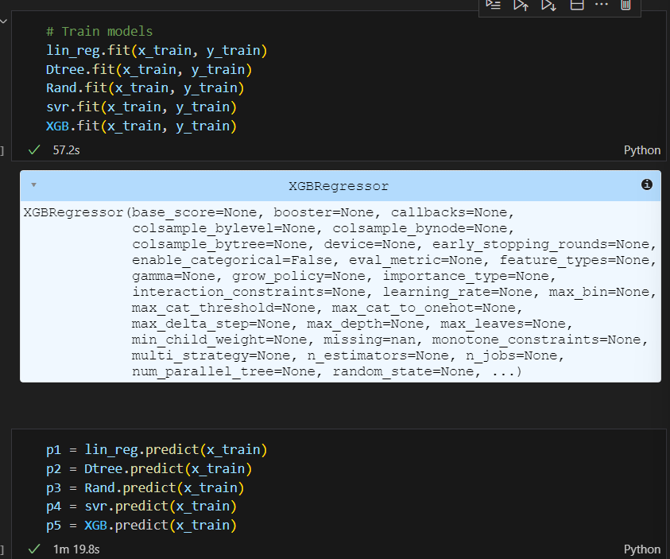

• A er considering both r squared values of test and train we concluded that random forest regressor is giving the be er value, it is able to explain the 97% of the data in train values. • Random forest gives the best r2-score, so we can select this model.

Activity 3.3: RMSE value

RMSE value for Random forest is very less when compared with other models, so saving the Random forest model and deploying using the following process

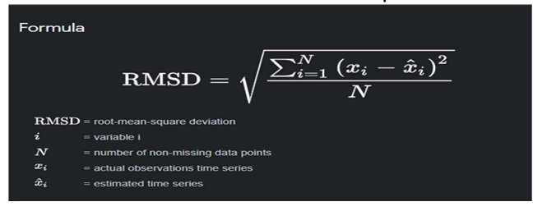

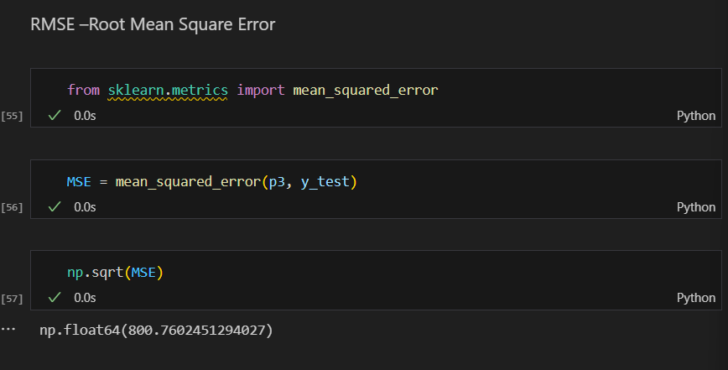

Activity 3.4: **Save the Model**

After building the model we have to save the model.

Pickle in Python is primarily used in serializing and deserializing a Python object structure. In other words, it's the process of converting a Python object into a byte stream to store it in a file/database, maintain program state across sessions or transport data over the network. wb indicates write method and rd indicates read method.

This is done by the below code

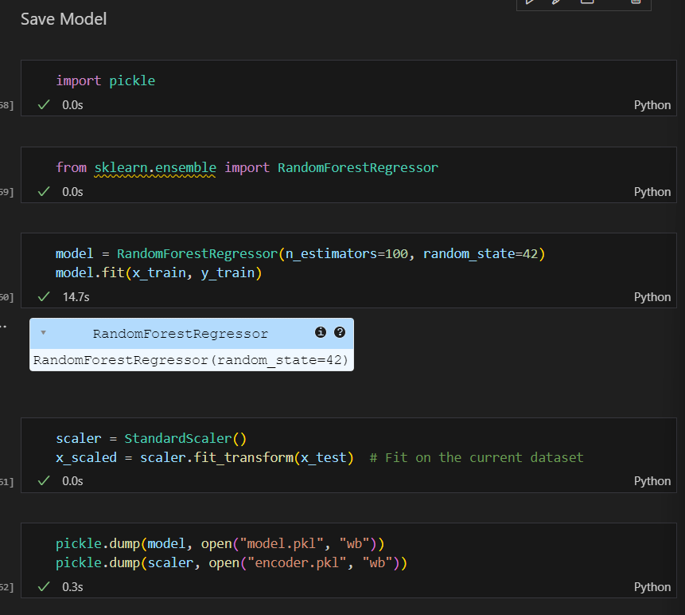

Activity 4: **Application Building**

In this section, we will be building a web application that is integrated into the model we built. A UI is provided for the uses where he has to enter the values for predictions. The enter values are given to the saved model and prediction is showcased on the UI.

This section has the following tasks

·         Building HTML Pages

·         Building server-side script

Acitivity 4.1: **Build HTML Code**

In this HTML page, we will create the front-end part of the web page. On this page, we will accept input from the user and Predict the values.  
For more information regarding HTML, click on the [link](https://www.w3schools.com/html/).

In our project we have HTML files, they are

**1.index.html**

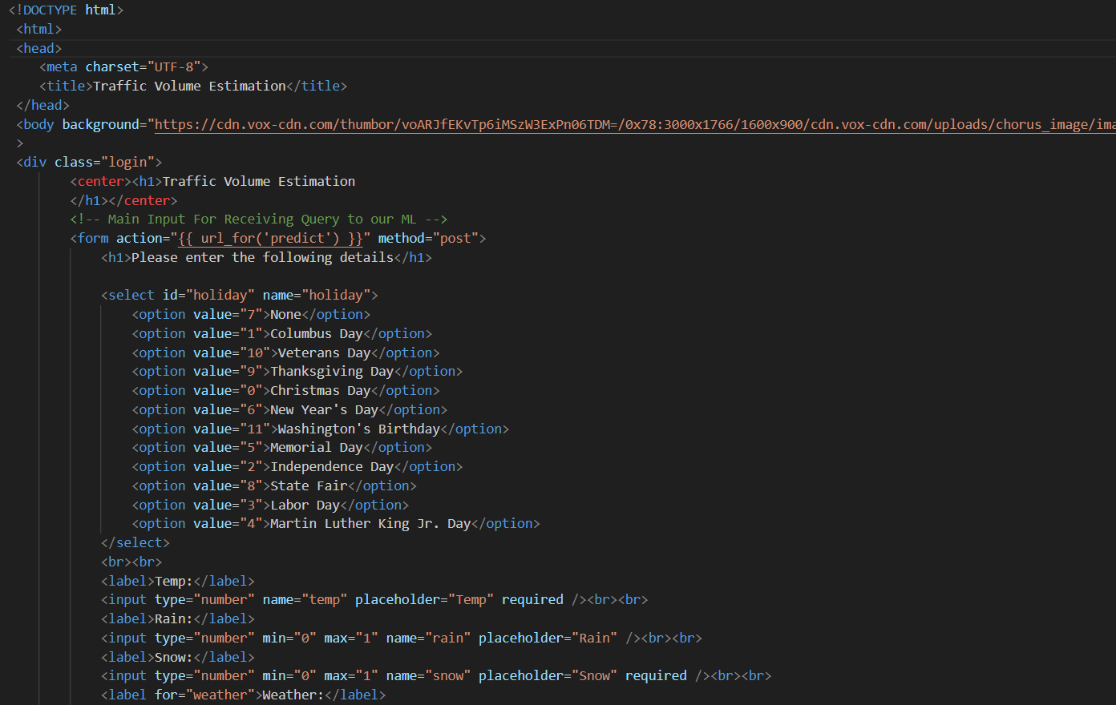

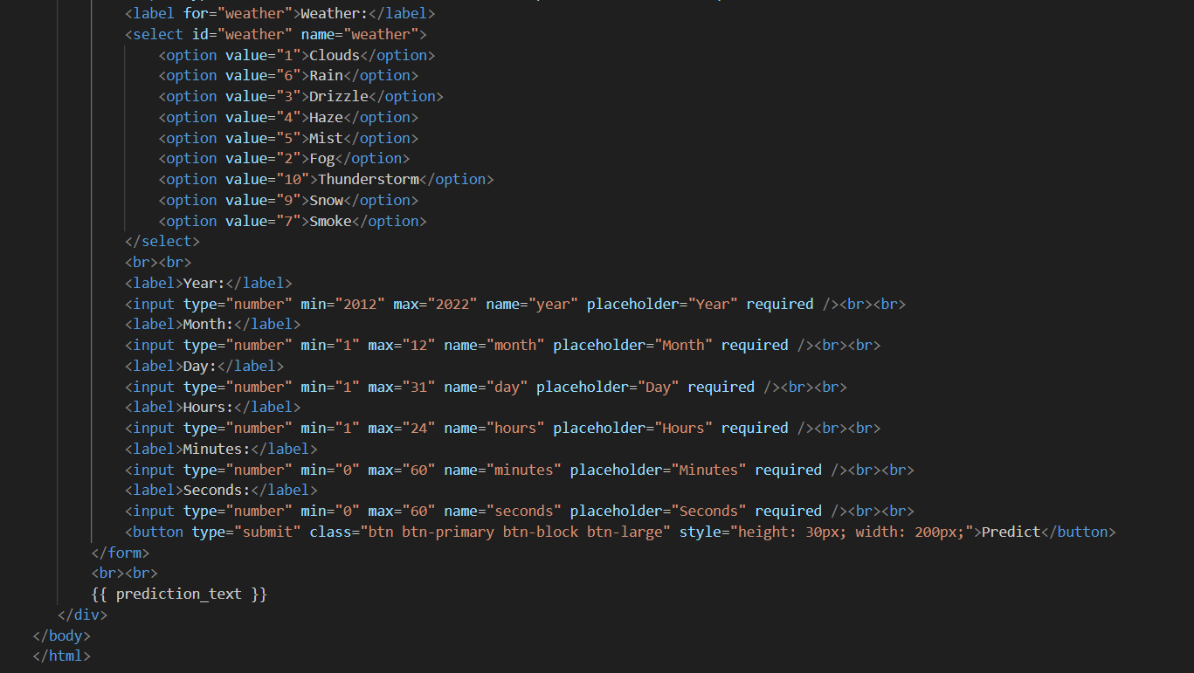

**2. The HTML page looks like this-**

Before enter Values:

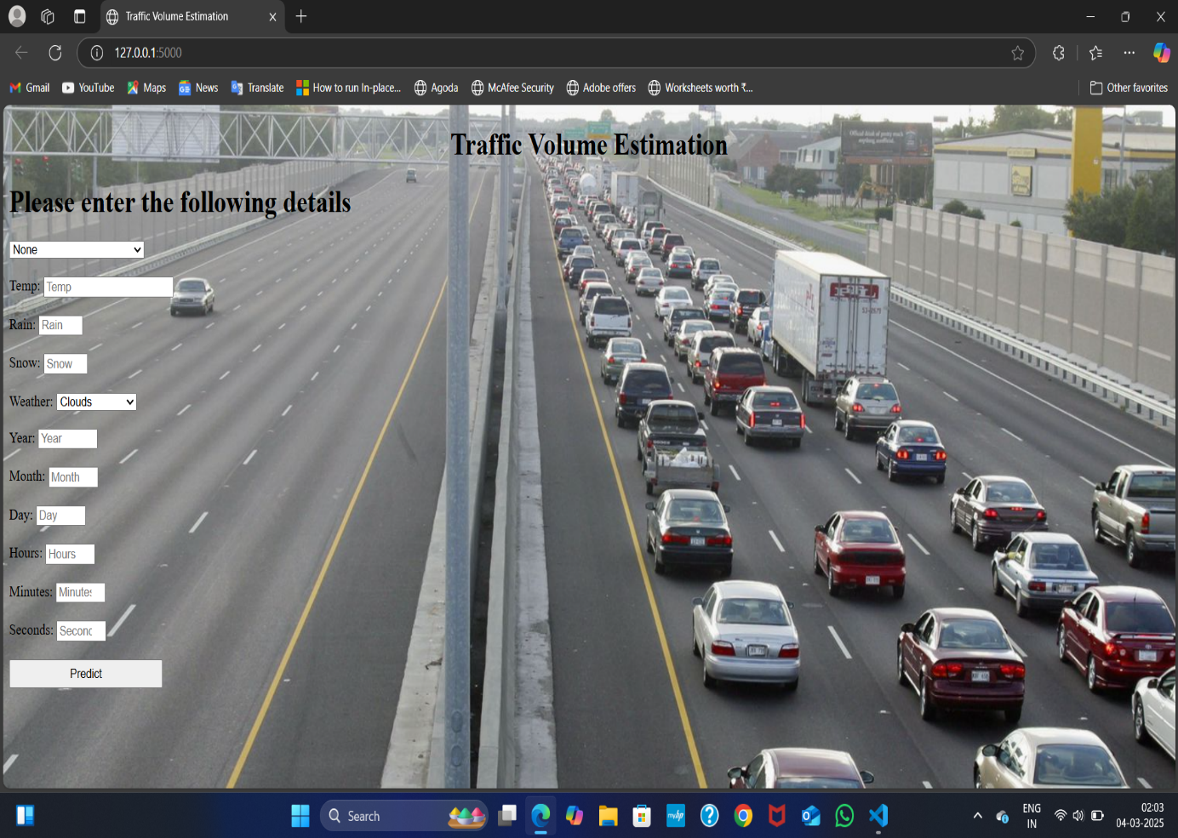

After enter values:

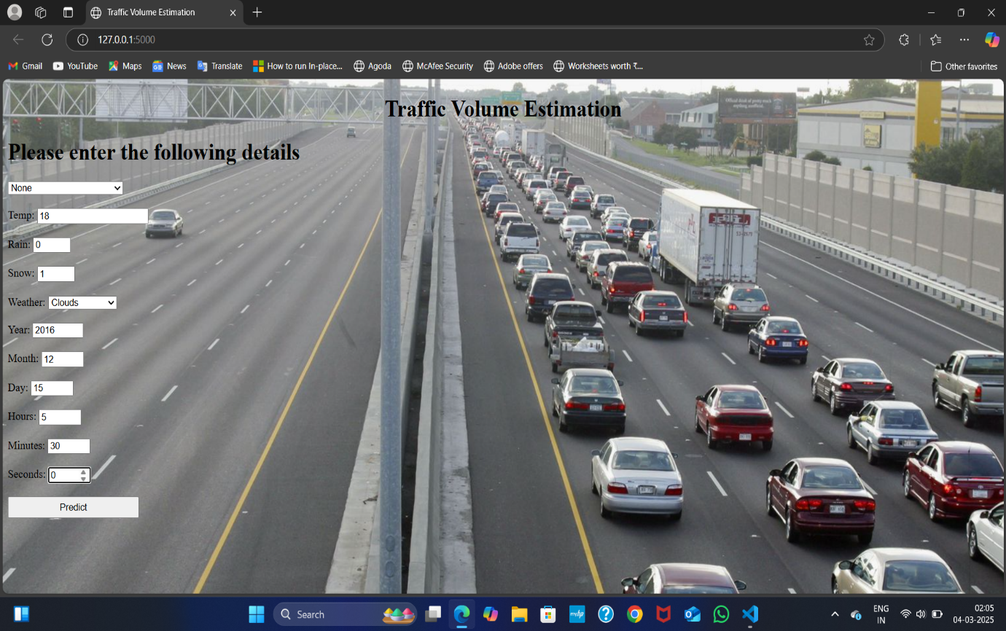

Now I create Output.html To print:

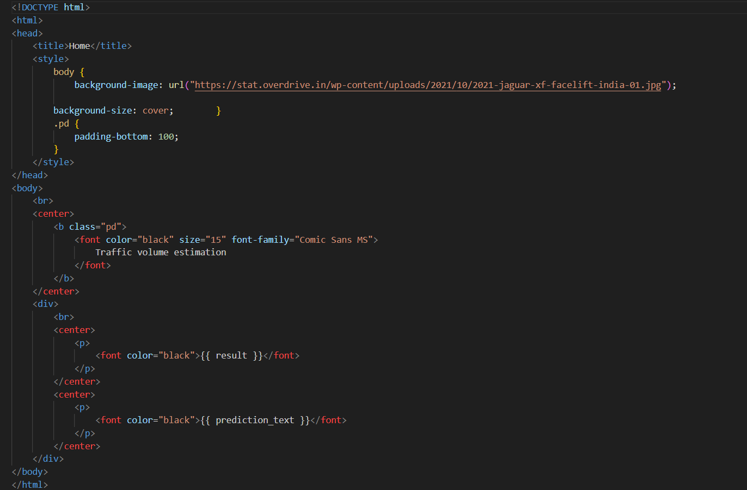

Activity 4.2: **Main Python Script as App.py**

Let us build an app.py flask file which is a web framework written in python for server-side scripting. Let’s see step by step procedure for building the backend application.

In order to develop web API with respect to our model, we basically use the Flask framework which is written in python.

Line 1-9  We are importing necessary libraries like Flask to host our model request

Line 12 Initialise the Flask application

Line 13 Loading the model using pickle

Line 16 Routes the API URL

Line 18 Rendering the template. This helps to redirect to the home page. In this home page,we give our input and ask the model to predict

In line 23 we are taking the inputs from the form

Line 28 Feature Scaling the inputs

Line 31 Predicting the values given by the user

Line 32-35 if the output is false render no chance template If the output is True render chance template

Line 36 The value of __name__ is set to __main__ when the module run as the main   program otherwise it is set to the name of the module.

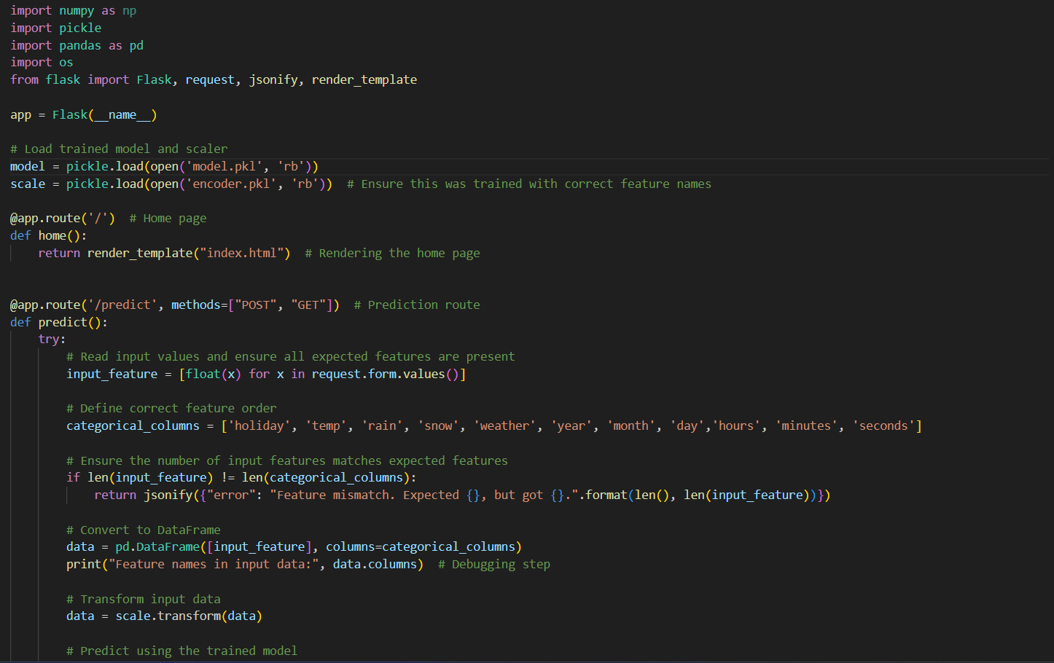

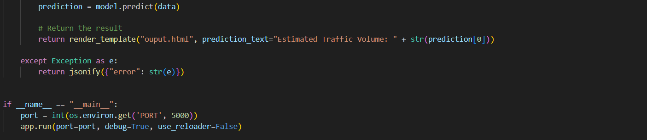

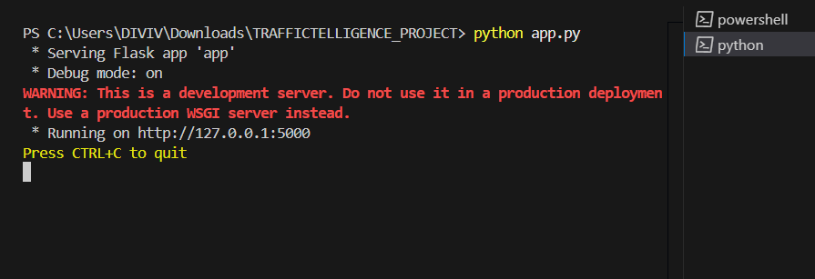

OUTPUT:

